1. Create a stored procedure that takes in IN parameters for all the columns in the Worker table and adds a new record to the table and then invokes the procedure call.

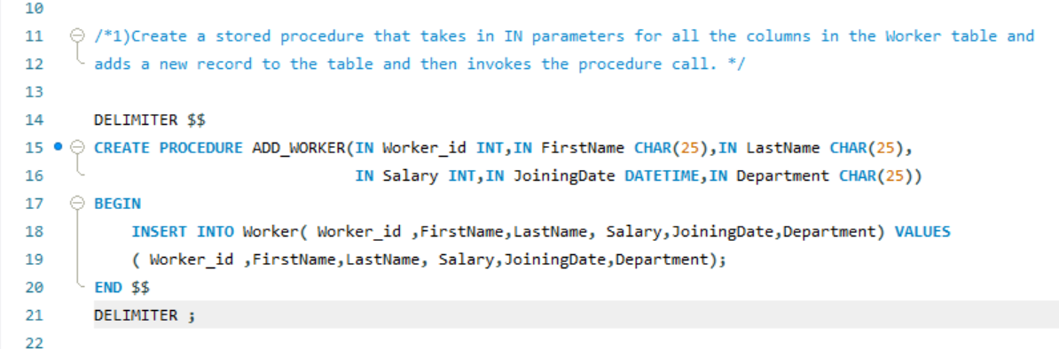

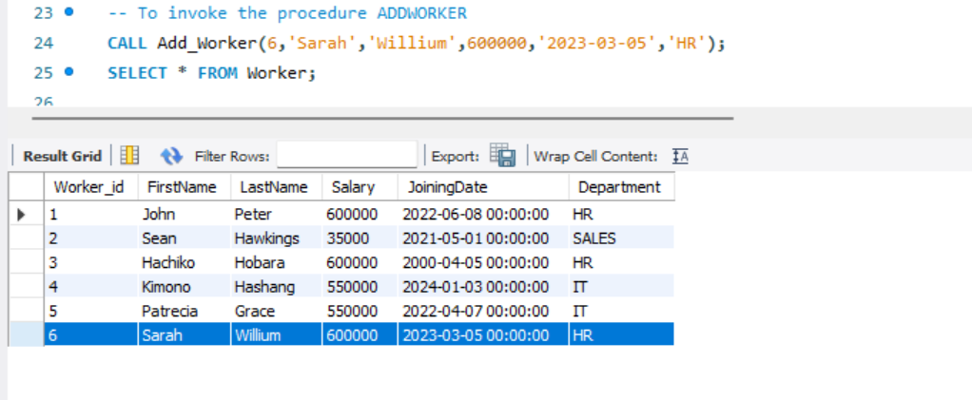

1. Write stored procedure takes in an IN parameter for WORKER_ID and an OUT parameter for SALARY. It should retrieve the salary of the worker with the given ID and returns it in the p_salary parameter. Then make the procedure call.

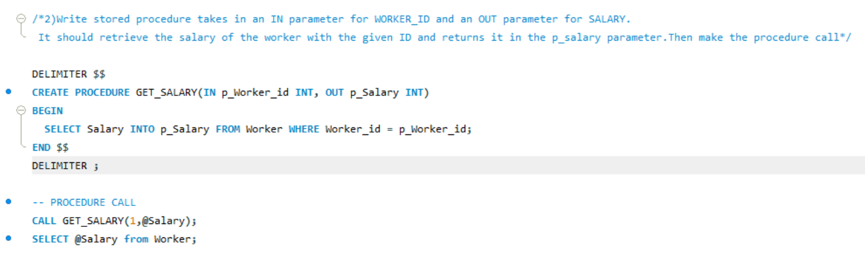

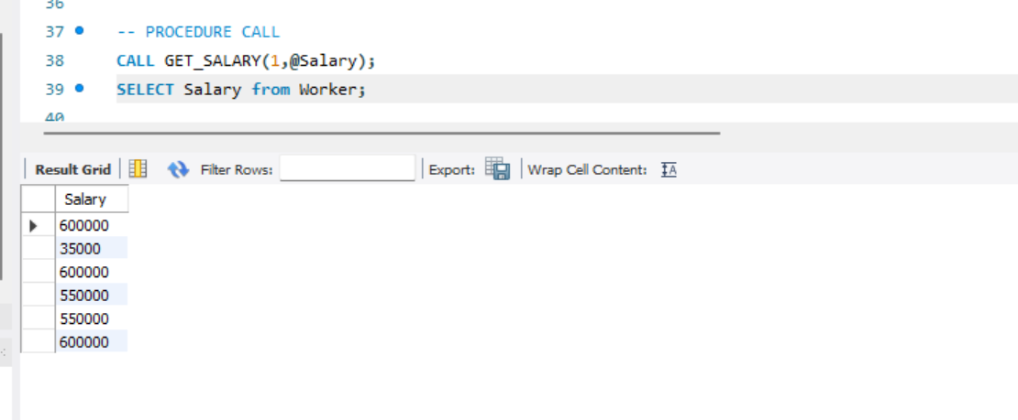

1. Create a stored procedure that takes in IN parameters for WORKER_ID and DEPARTMENT. It

should update the department of the worker with the given ID. Then make a procedure call.

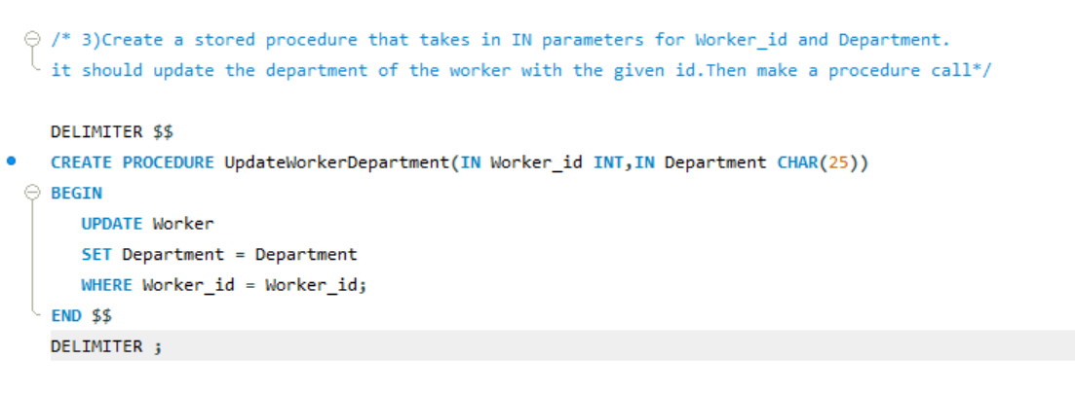



1. Write a stored procedure that takes in an IN parameter for DEPARTMENT and an OUT parameter for p_workerCount. It should retrieve the number of workers in the given department and returns it in the p_workerCount parameter. Make procedure call.

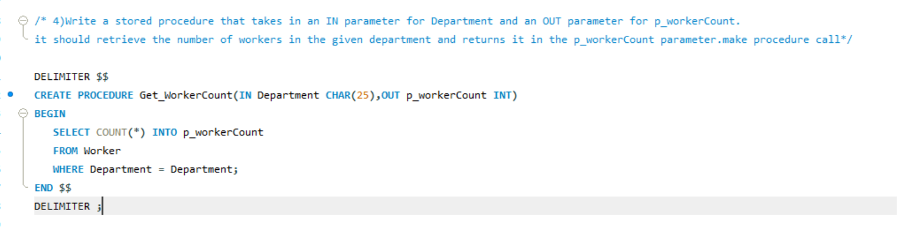

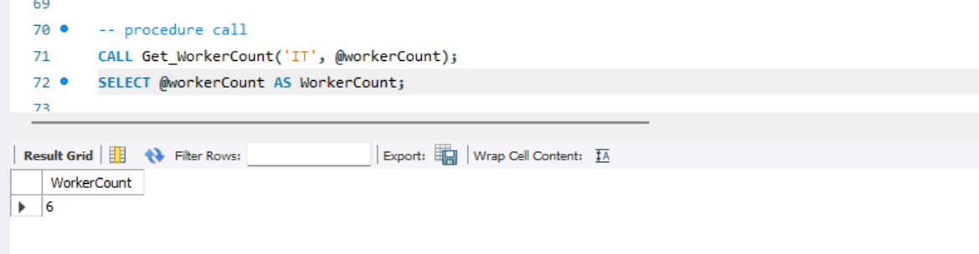

1. Write a stored procedure that takes in an IN parameter for DEPARTMENT and an OUT parameter for p_avgSalary. It should retrieve the average salary of all workers in the given department and returns it in the p_avgSalary parameter and call the procedure.

